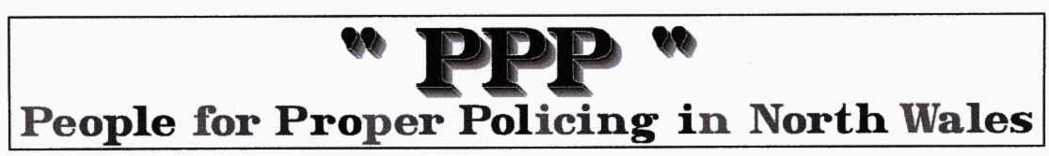
Rubbish from North Wales sent all over world.
Dec 3 2007 by Tom Bodden, Daily Post

RUBBISH which North Wales people are told to leave by the kerb for recycling is being packed in ships and sent halfway across the globe.

Politicians last night condemned what they consider the wasteful and environmentally unfriendly method of sending rubbish to India, China, Brazil and other countries to be recycled.

Six councils across Wales – including Denbighshire, Flintshire and Powys – are sending recyclable rubbish abroad. Seven other local authorities either did not know where the items they collected for recycling were sent to – or admitted it was possible they were exported from Britain.

Plaid Cymru’s sustainability spokesman, Leanne Wood AM, said the news would come as a shock to many who believed they were helping the environment by recycling and had “grave implications” for the environment.

“It is clear a not insignificant amount of Wales’ kerbside recycling waste ends up being processed in countries such as China and India. People who diligently recycle their waste do not expect it to be travelling that far. This has grave implications, not only for the exploitation of the workers paid peanuts to pick through the rubbish, but also from an environmental perspective. It’s hardly the most sustainable policy and grossly counter-productive.”

Ms Wood is now calling for a policy review.

Denbighshire council, which collects 26% of waste for recycling or composting, listed the Netherlands, Ireland and China as countries which received its plastics, while glass was transported to France, Spain and Portugal.

“Some recyclable material may end up in overseas markets but all the council's waste is sent to UK re-processors or merchants,” a spokesman said.

Waste such as plastic pop bottles was exported for recycling.

“The council does not specify that materials must be processed in the UK as this would put a severe limitation on our recycling operations,” he said.

Flintshire, which recycles a third of its domestic rubbish, said plastic film went to China; some recycling to Ireland; while some textiles were sent to where there was a need for clothing, such as eastern Europe and developing countries.

Mixed cans collected in Powys were exported to Tianjin in China.

A Flintshire council spokesman said: “All recyclable materials collected are sent to licensed re-processors within the UK.

“The majority of the materials are fully recycled within a 100 mile radius of Flintshire, including in Shotton, Warrington and Ellesmere Port. However some materials are subject to market forces.

“Due to high demand, some plastics are being recycled in China through our UK-based reprocessor, who sort the plastic into different streams.

“The UK reprocessor places the same terms and conditions on the processors whether in Europe or the Far East. The plastic is sent for recycling and not for disposal.

“Our textiles are collected through charities who in turn re-use/recycle some of the clothes in Eastern European/developing countries where there is a high demand.

“All markets are audited to ensure they are licensed before we agree to send materials to them. No residual waste is exported.”

A Denbighshire spokesman said the county sought to recycle or dispose of all rubbish as close as possible to where it is produced.

“Of 16,600 tonnes of municipal waste recycled by Denbighshire residents in 2006/07, around 53% was recycled in Wales, 40% elsewhere in the UK and 7% sent abroad,” he said.

“The Welsh Assembly are consulting councils on new recycling targets as high as 70%. Given the shortage of recycling capacity in the UK this policy could result in more material being exported in the short to medium term.”

The PPP comment ………we include this story from the Daily Post on our website because we really need in depth reporting by the press to tell us what is going on……..we congratulate the Post and Tom Bodden on this article. We find the comments by the politicians, as expected, disappointing and lacking in possitivity. The councils are responding quite effectively to waste reduction targets set by the assembly with little thought to the HOWs and WHEREs.
For instance our Nuclear power stations, including Wylfa, need to recycle fuel waste and other weakly radioactive waste. Sellafield was built for this purpose and took international waste. The Chinese economy is growing so fast their entrepreneurs take much of Europe’s scrap cars for their steel industry and so on. If Welsh Politicians encouraged such entrepreneurial activity in Wales, including real recycling our economy would not be so dependent on handouts from the EU etc!.

In conclusion we would appreciate similar in depth articles on issues that concern the PPP … such as where does the £140 million we spend on Policing in North Wales go to? and where are all our Police Officers?

